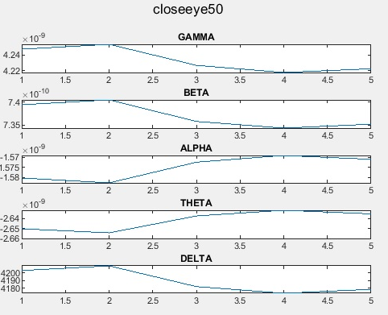

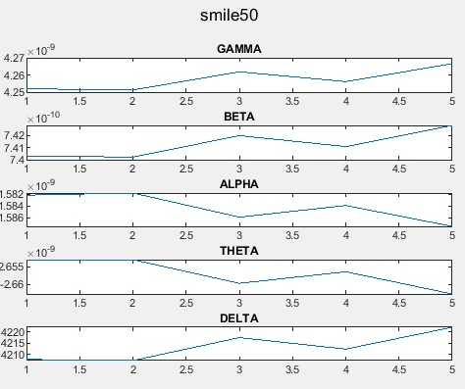

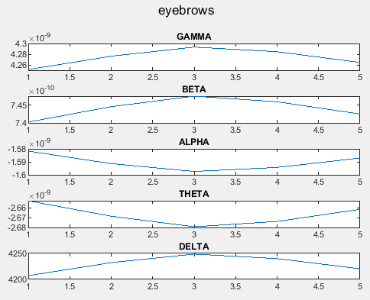

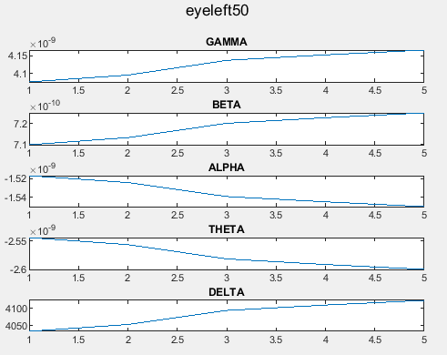

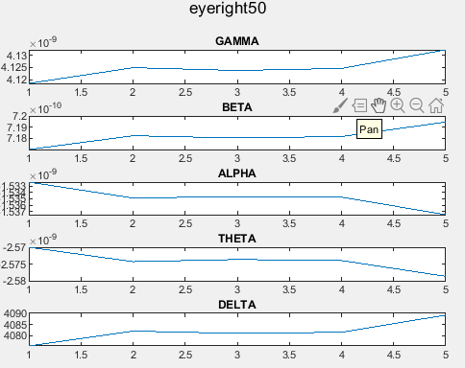

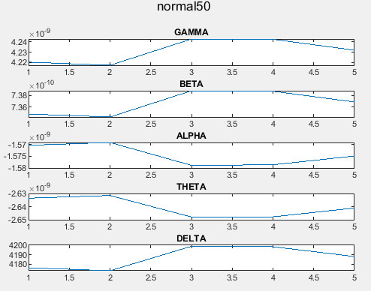

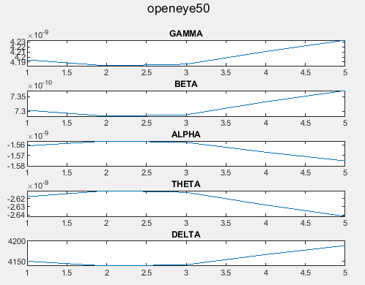

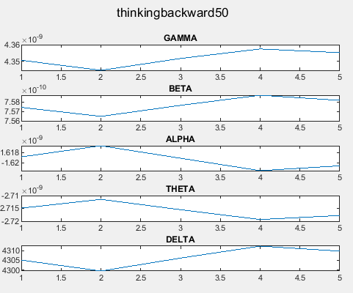

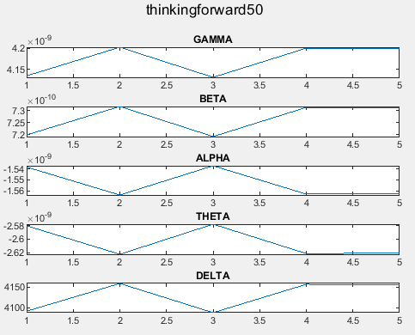

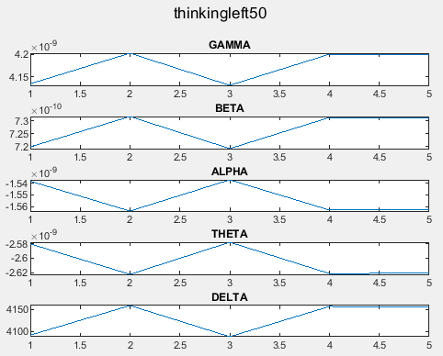

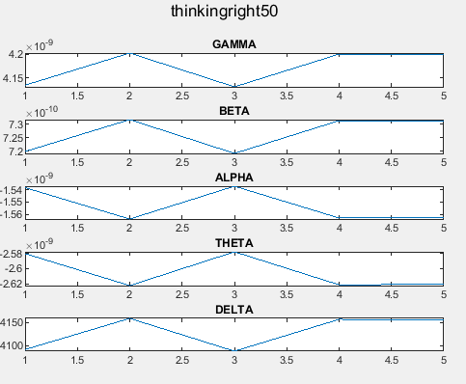

All the above waveforms are different from one another. This means that different signal is generated by brain for each of the above emotions. This also verifies the correctness of data.

The Matlab Code for Generating the Above Waveforms

data = thinkingright50

titleplot = "thinkingright50";

c = data{:,4:8};%4-8 is our actual data; 1 is counter; 2 is ...; search ied counter emotiv epoc

[n,p] = size(data);

t=1:n;

%figure()

%plot(t,c);%plot of close eye raw data

s=c(1);

fs = 128;%sampling feq from web site

N=length(s);

%s=eegdata;

%figure;p=plot(s);

%title('EEG Signal')

%fs = 500;

% Sampling frequency Not a code

%N=length(s);

waveletFunction = 'db8';

DD5=[];

DD6=[];

DD7=[];

DD8=[];

AA8=[];

for channel = 1:5

s= c(channel);

[C,L] = wavedec(s,8,waveletFunction);

cD1 = detcoef(C,L,1);

cD2 = detcoef(C,L,2);

cD3 = detcoef(C,L,3);

cD4 = detcoef(C,L,4);

cD5 = detcoef(C,L,5); %GAMA

cD6 = detcoef(C,L,6); %BETA

cD7 = detcoef(C,L,7); %ALPHA

cD8 = detcoef(C,L,8); %THETA

cA8 = appcoef(C,L,waveletFunction,8); %DELTA

D1 = wrcoef('d',C,L,waveletFunction,1);

D2 = wrcoef('d',C,L,waveletFunction,2);

D3 = wrcoef('d',C,L,waveletFunction,3);

D4 = wrcoef('d',C,L,waveletFunction,4);

D5 = wrcoef('d',C,L,waveletFunction,5); %GAMMA

D6 = wrcoef('d',C,L,waveletFunction,6); %BETA

D7 = wrcoef('d',C,L,waveletFunction,7); %ALPHA

D8 = wrcoef('d',C,L,waveletFunction,8); %THETA

A8 = wrcoef('a',C,L,waveletFunction,8); %DELTA

DD5 = [DD5, D5];

DD6 = [DD6, D6];

DD7 = [DD7, D7];

DD8 = [DD8, D8];

AA8= [AA8, A8];

end

Gamma = DD5;

figure();

sgtitle(titleplot);

subplot(5,1,1); plot(1:1:length(Gamma),Gamma);title('GAMMA');

Beta = DD6;

subplot(5,1,2); plot(1:1:length(Beta), Beta); title('BETA');

Alpha = DD7;

subplot(5,1,3); plot(1:1:length(Alpha),Alpha); title('ALPHA');

Theta = DD8;

subplot(5,1,4); plot(1:1:length(Theta),Theta);title('THETA');

% D8 = detrend(D8,0);

Delta = AA8;

%figure, plot(0:1/fs:1,Delta); Not a code

subplot(5,1,5);plot(1:1:length(Delta),Delta);title('DELTA');